**Pizza Project**

**Women in STEM**

**By Katie Buell, Thuy Dong, Issabella Du, and Hailey Walker**

1. **Application Screenshots**

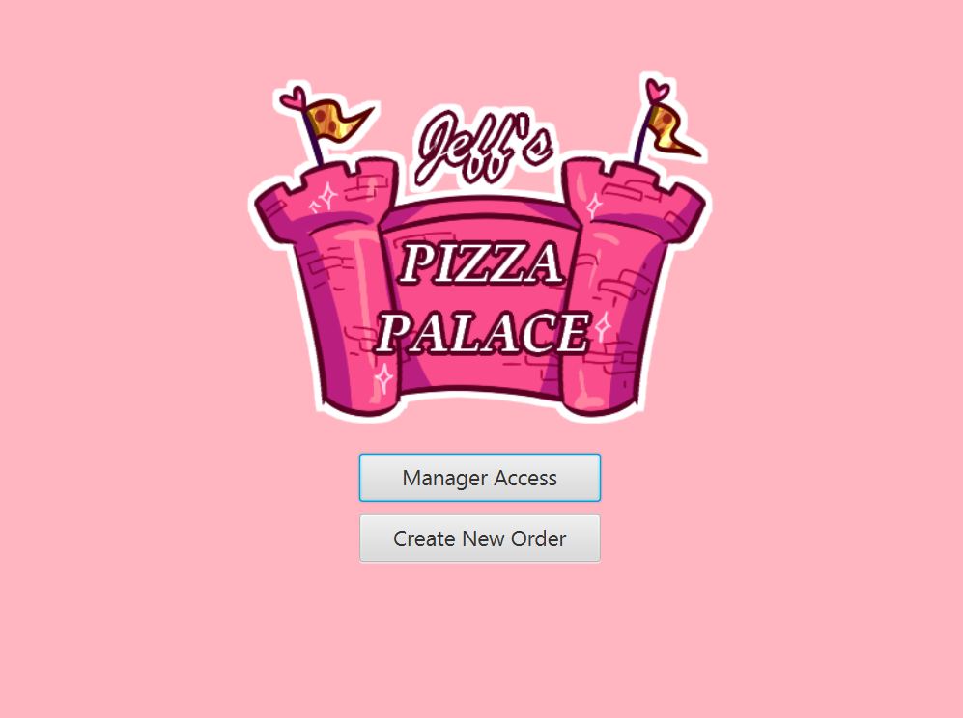

This screen is accessed by running the program.

This screenshot addresses the following requirement(s): Order Creation Security

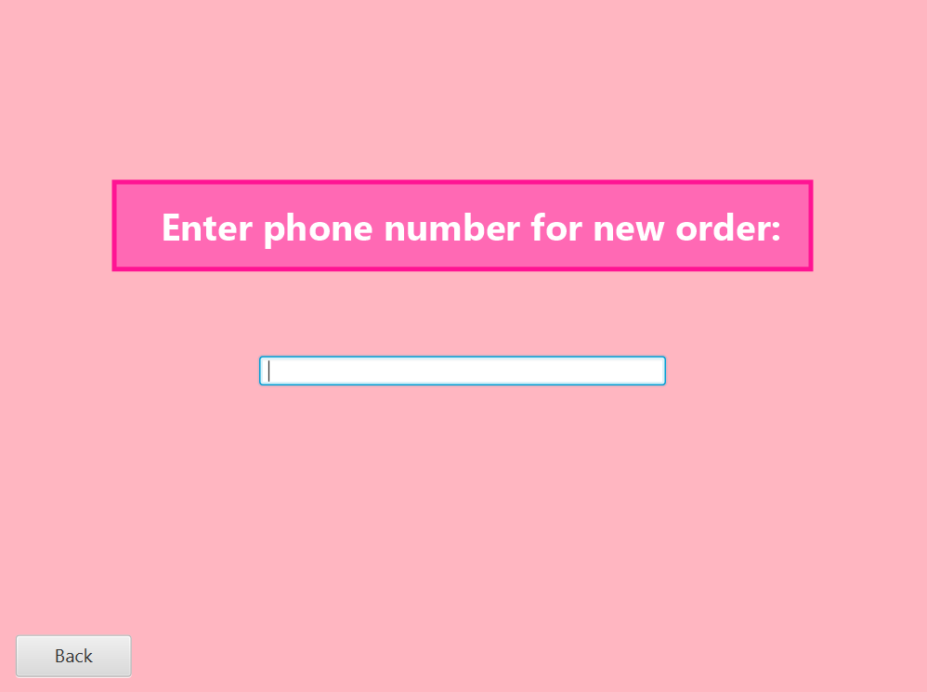

This screen is accessed by selecting "Create New Order" on

This screenshot addresses the following requirement(s): Order Creation, Order Creation Security, Record Information, Previous Customers

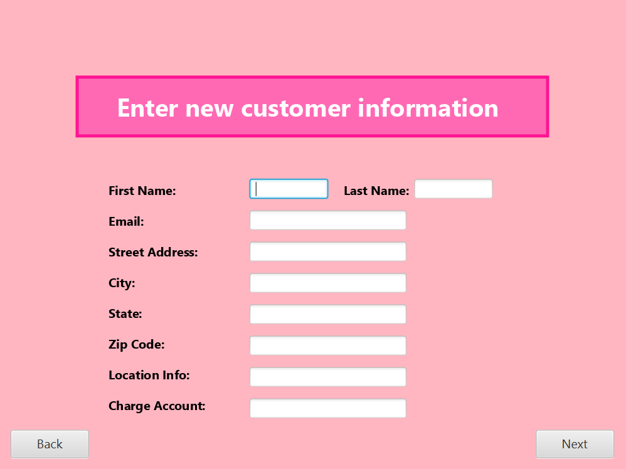

This screen is accessed by entering a phone number that does not already have an attached customer.

This screenshot addresses the following requirement(s): Record Creation, Record Information, Record Storage

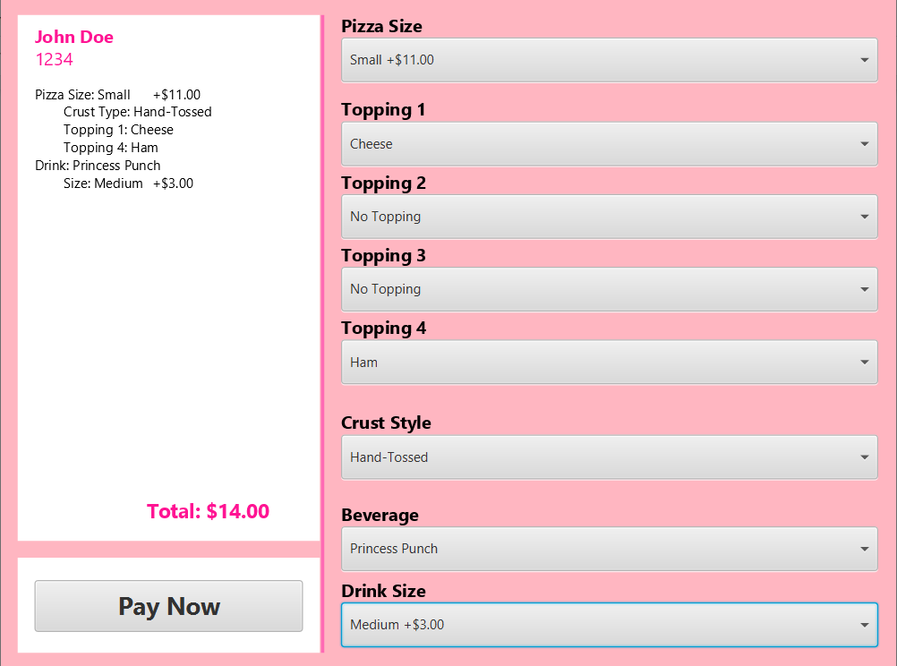

This screen is accessed after a phone number is recognized or a new customer is created.

This screenshot addresses the following requirement(s): Menu GUI, Order Creation, Order Total, Order Options, Order Creation Security

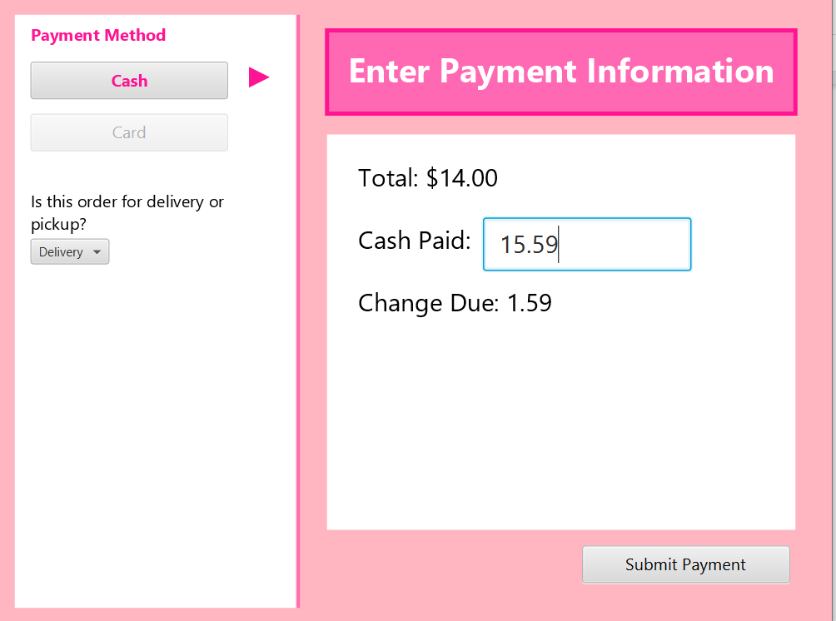

This screen is accessed by clicking “Pay now” then “Cash”.

This screenshot addresses the following requirement(s): Payment Processing, Payment Storage

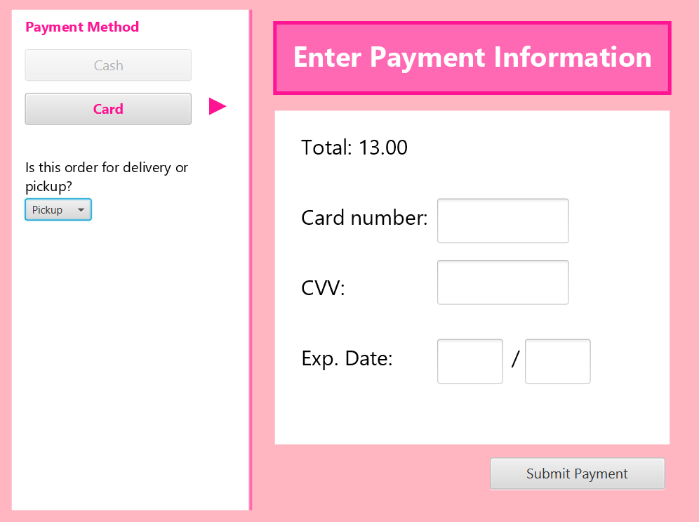

This screen is accessed by clicking “Pay now” then “Card”.

This screenshot addresses the following requirement(s): Payment Processing, Payment Storage

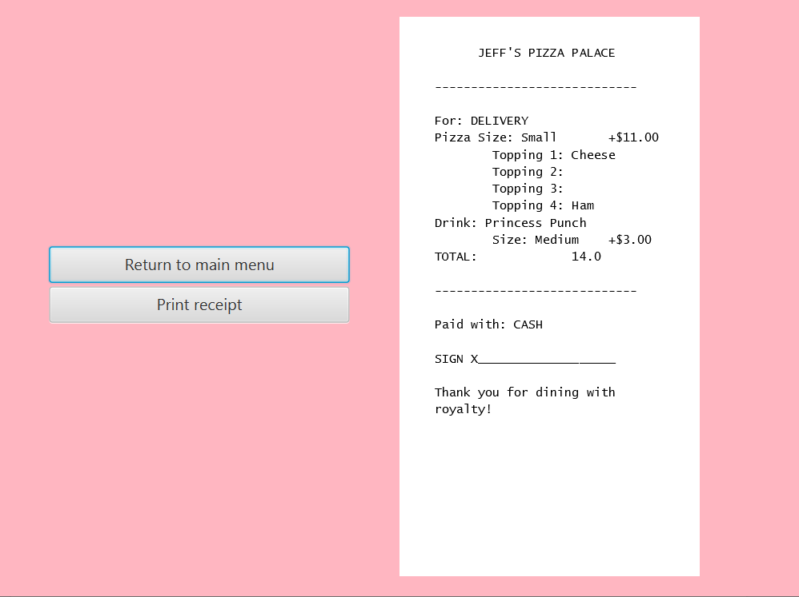

This screen is accessed by clicking “Submit Payment”.

This screenshot addresses the following requirement(s): Receipt Printing

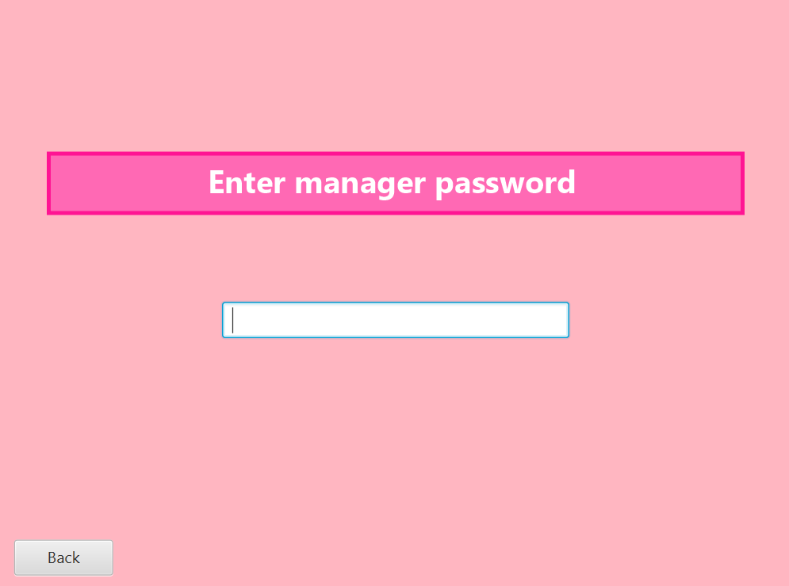

This screen is accessed by choosing “Manager Access” on the first screen.

This screenshot addresses the following requirement(s): Record Security

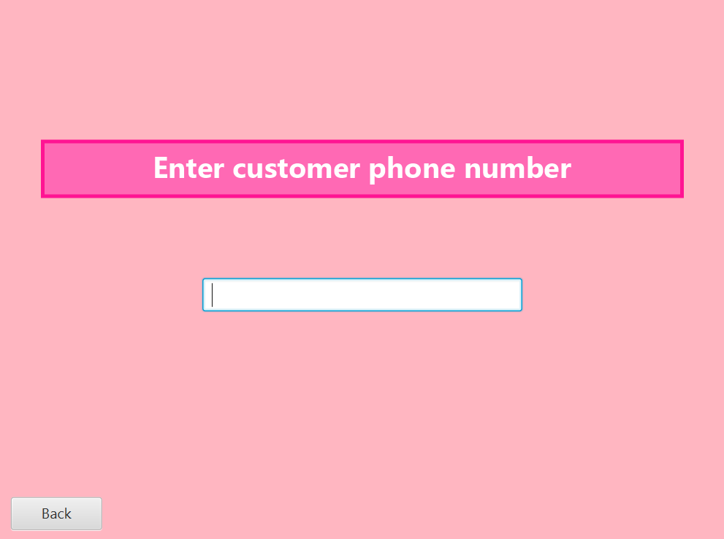

This screen is accessed if the manager’s password is correct.

This screenshot addresses the following requirement(s): Record Access, Record Security

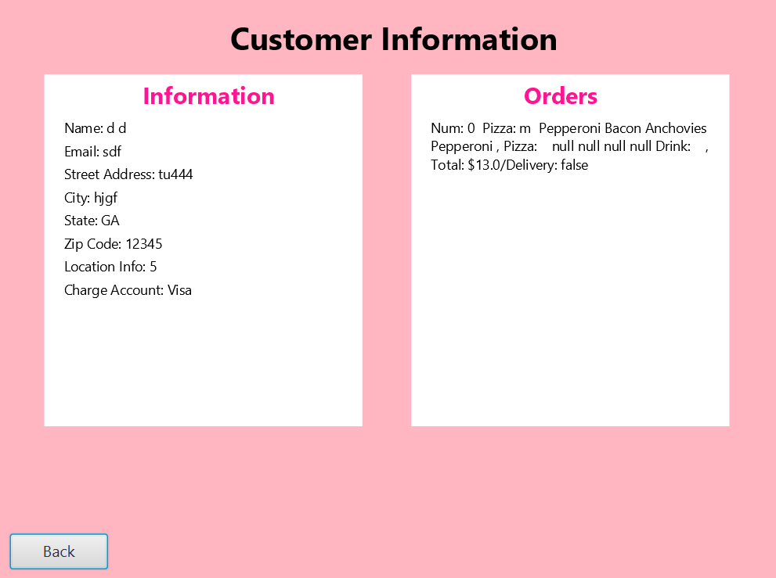

This screen is accessed after the manager password and customer phone number are recognized.

The screenshot address the following requirement(s): Record Information, Payment storage, Previous Customers, Record Security

1. **Your source code (zipped)**

* In the zipped file.

1. **Brief instructions how to compile your source code**

* Step 1: Have IntelliJ IDEA installed.
* Step 2: Download the source code. Extract the files from the zipped file.
* Step 3: Open IntelliJ. and click Open on the startup window. Navigate to the extracted file and select the file "java-io".
* Step 4: Ensure that the Main method is selected in the Run Configurations panel on the top right.
* Step 5: Click run to open the program

1. **Your compiled executable file (.exe or .jar)**

* We have no executable file, only the source code. We hope this is enough to be able to load the application to see how well it works.

1. **Brief instructions how to start the executable**

* We tried so hard to make it a .exe or .jar file but we just couldn’t. Here are the instructions if it had worked:
* Step 1: Open Executable (EXE) files on Windows.
* Step 2: Double - click on the file to open it.
* Step 3: Press the **Start menu** **icon** (or hit the **Windows key** on the keyboard), then press one of the entries to run the software.
* Step 4: Press the **Windows key + R** on the keyboard to use the Run command box to run the EXE file.
* Step 5: Run command box by locating the executable file by pressing **Browse**, or type the file location directly. Then press OK to run the EXE file.
* Step 6: Press YES to allow the EXE file to run in the UAC pop-up.
* Note: If the EXE file cannot run, The Window will stop running it. An error message will appear on the screen, click **Close** and look for an alternative version of the file to run instead.